Introduction :
- It is the premium network analysis tool for information security professionals .
- It is simpler than wireshark .

Options :

1.tcpdump -i any - listen to all interfaces for traffic

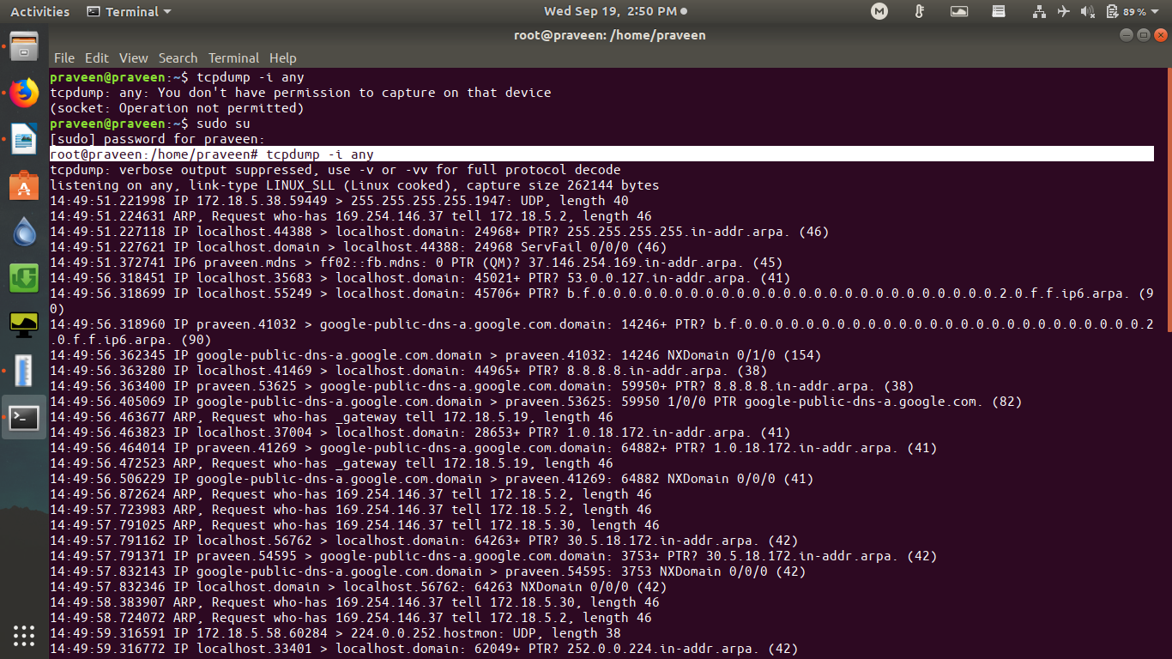

2. tcpdump -i eno1 : Listen on the eno1 interface
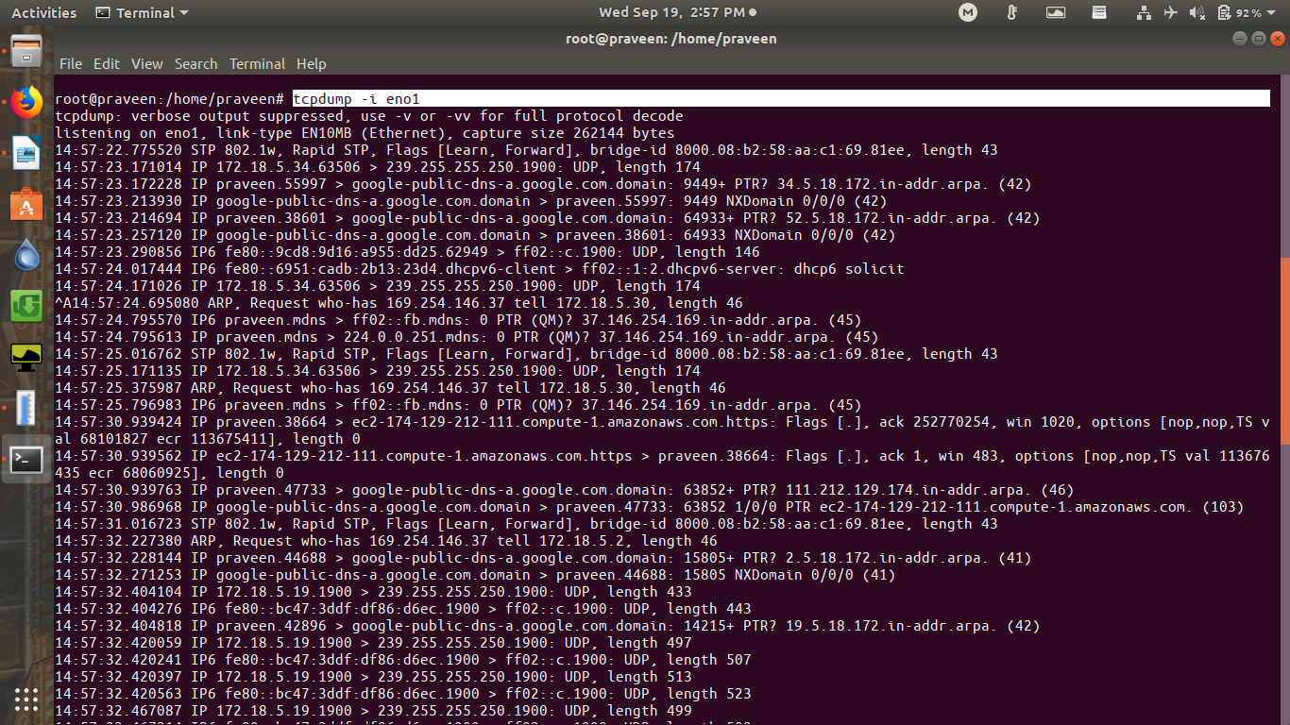
3 . tcpdump -D : show the list of available interfaces

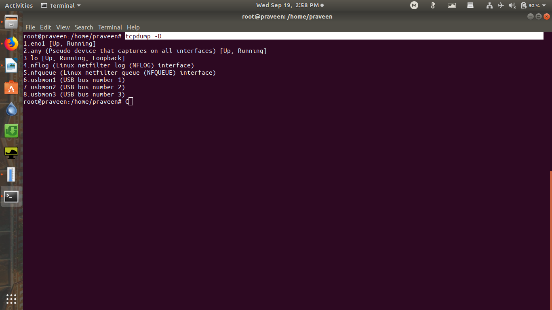

4. tcpdump host <ip_addr> - find traffic by ip address
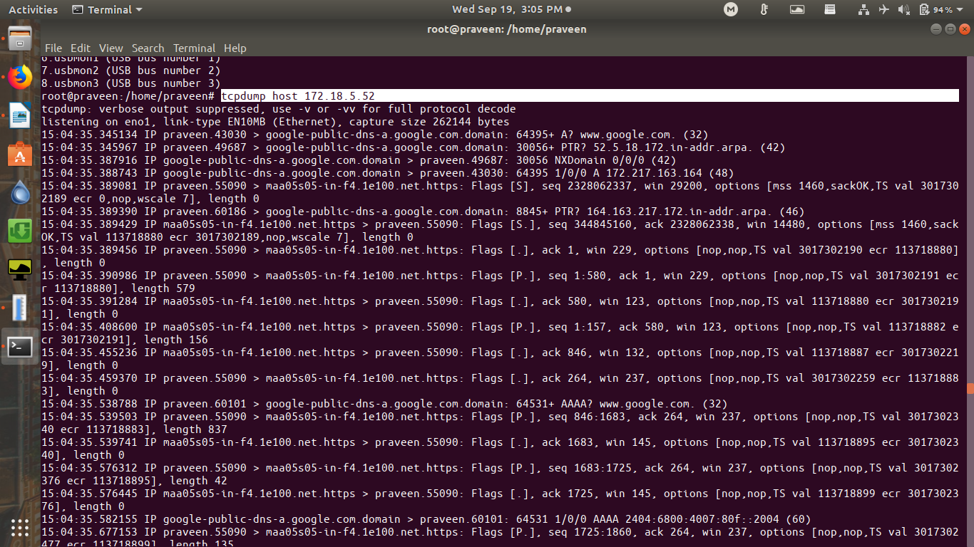

5 . tcpdump net <subnet_mask> - find packets by subnet

6 . tcpdump port <number> - filter traffic by port number
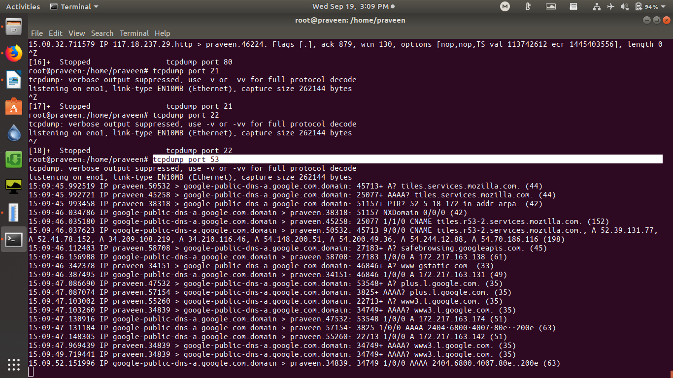

7 . tcpdump <protocol> - filter traffic by protocol

